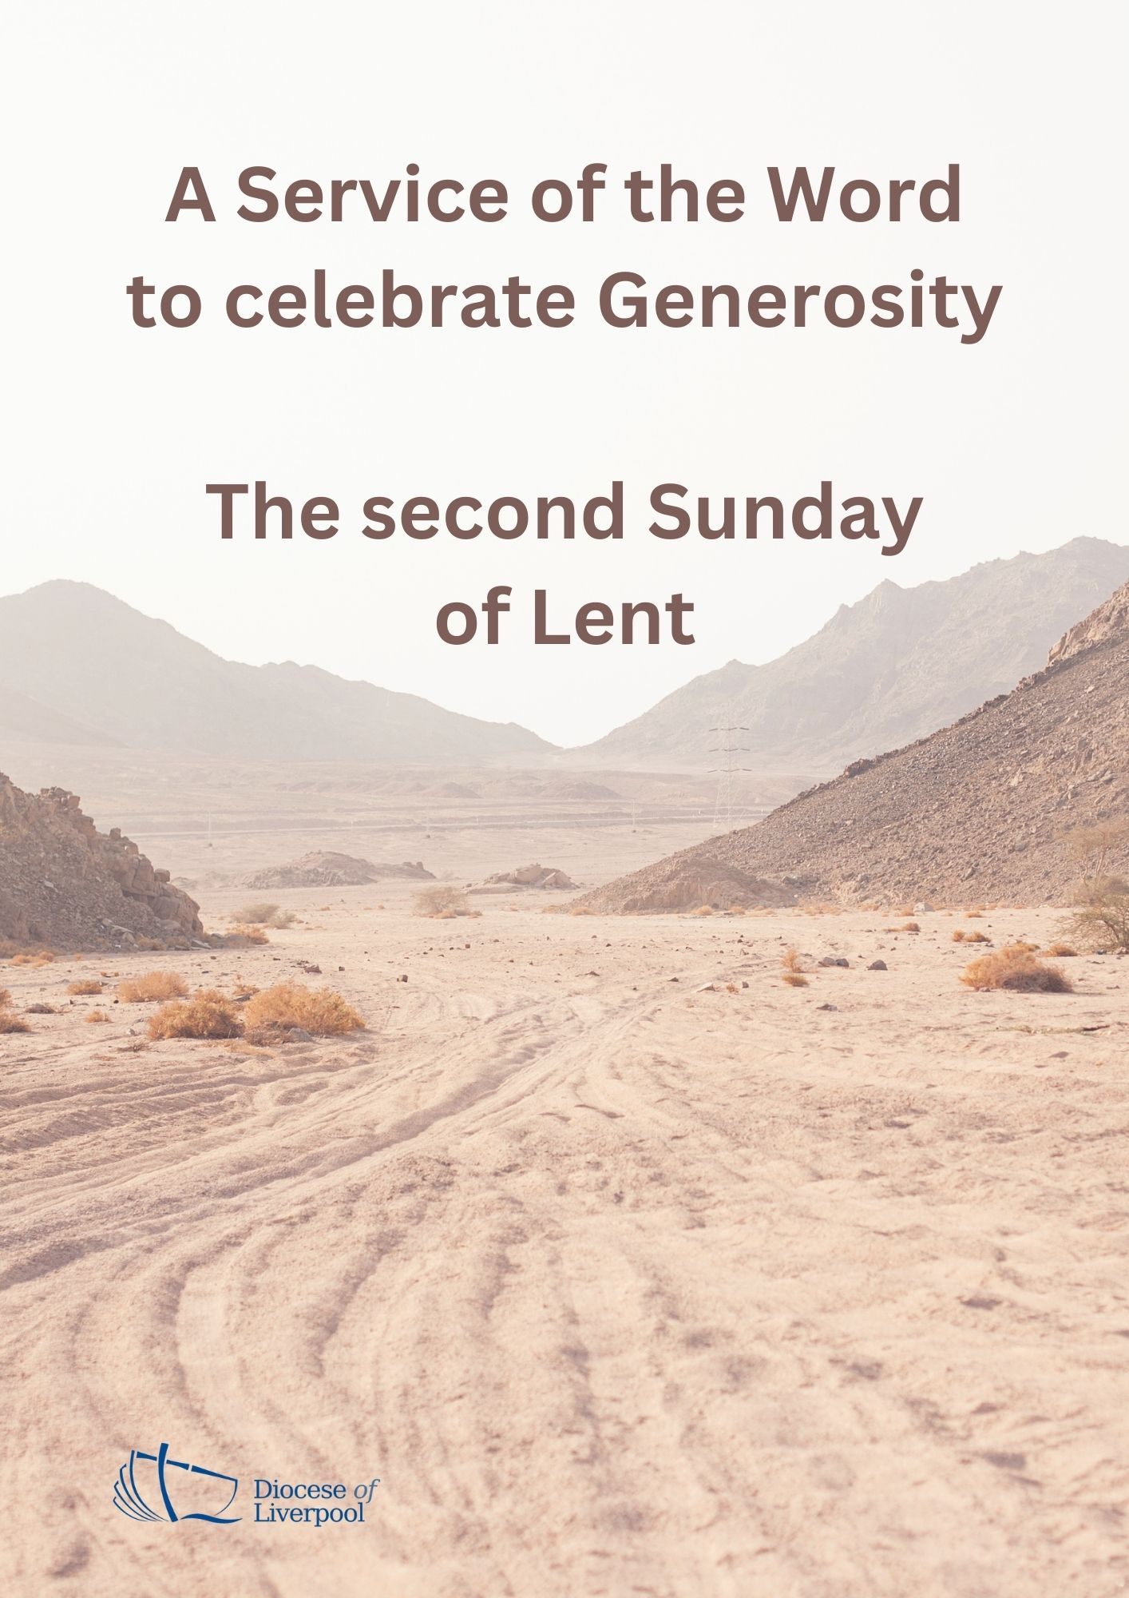

PREPARATION

In preparation for this act of worship, you might wish to pray privately this Ignatian Prayer for Generosity.

Lord, teach me to be generous.
Teach me to serve you as you deserve;
to give and not to count the cost,
to fight and not to heed the wounds,
to toil and not to seek for rest,
to labour and not to ask for reward,
save that of knowing that I do your will.
Amen.

PREPARATION

In the name of the Father,
and of the Son,
and of the Holy Spirit.
Amen.

God is able to provide us with every blessing in abundance,
so that by always having enough of everything,
we may share abundantly in every good work. 2 Corinthians 9.8

A prayer for generous discipleship
O God,
help us, this day, to be
open to your generous gift of love,
to share our faith with willingness,
to delight in the beauty of your creation,
to seek you out in the people we meet,
to know you in the quietness,
to sense you in the busyness.
This we pray in the name of Jesus.
Amen. (Church in Wales)

Prayers of Penitence

As we journey together through the obedience of Lent,
we remember the times when we have not received gratefully and gladly
or shared generously and graciously of all our generous God has given to us.

Father, you give to us your Son,
yet we receive grudgingly;
Lord, have mercy.
Lord, have mercy.

Jesus, you made yourself poor, that we might become rich,
yet we hoard our possessions and forget to live by your example;
Christ, have mercy.
Christ, have mercy.

Holy Spirit, you bless us with the fruit of generosity,
yet we fail to respond to your call;
Lord, have mercy.
Lord, have mercy.

May the God of all healing and forgiveness
draw us to himself and cleanse us from all our sins,
that we may behold the glory of his Son,
Jesus Christ our Lord.
Amen.

Canticle: A Song of David

Splendour and majesty are yours, O God;
you are exalted as head over all.
1 Blessed are you, God of Israel, for ever and ever,
for yours is the greatness, the power,
the glory, the splendour and the majesty.
2 Everything in heaven and on earth is yours;
yours is the kingdom, O Lord,
and you are exalted as head over all.
3 Riches and honour come from you
and you rule over all.
4 In your hand are power and might;
yours it is to give power and strength to all.
5 And now we give you thanks, our God,
and praise your glorious name.
6 For all things come from you,
and of your own have we given you. 1 Chronicles 29.10b-13,14b

Glory to the Father and to the Son
and to the Holy Spirit;
as it was in the beginning is now
and shall be for ever. Amen.
Splendour and majesty are yours, O God;
you are exalted as head over all.

The Collect

Almighty God,
by the prayer and discipline of Lent
may we enter into the mystery of Christ’s sufferings,
and by following in his Way
come to share in his glory;
through Jesus Christ our Lord. Amen

God, from whom all good things come,
you shower us with blessings
and you make us stewards of your world;
give us generous hearts,
make us cheerful givers,
filled with desire to see the dawning of the Kingdom
of your Son our Saviour Jesus Christ.
Amen (Diocese of Gloucester)

A children's talk or an all age activity may take place at this point

THE LITURGY OF THE WORD

The First Reading

Remember this: whoever sows sparingly will also reap sparingly, and whoever sows generously will also reap generously. Each of you should give what you have decided in your heart to give, not reluctantly or under compulsion, for God loves a cheerful giver.
And God is able to bless you abundantly, so that in all things at all times, having all that you need, you will abound in every good work.
Now he who supplies seed to the sower and bread for food will also supply and increase your store of seed and will enlarge the harvest of your righteousness. You will be enriched in every way so that you can be generous on every occasion, and through us your generosity will result in thanksgiving to God.
This service that you perform is not only supplying the needs of the Lord’s people but is also overflowing in many expressions of thanks to God.
2 Cor 9:6-8, 10-12
This is the Word of the Lord.
Thanks be to God.
Psalmody: Psalm 23

Surely your goodness and love will follow me
all the days of my life.

1 The Lord is my shepherd, I lack nothing.
2 He makes me lie down in green pastures,
he leads me beside quiet waters,

3 he refreshes my soul.
He guides me along the right paths
for his name’s sake.

4 Even though I walk
through the valley of the shadow of death
I will fear no evil, for you are with me;
your rod and your staff, they comfort me.

5 You prepare a table before me
in the presence of my enemies.
You anoint my head with oil;
my cup overflows.

6 Surely your goodness and love will follow me
all the days of my life,
and I will dwell in the house of the Lord for ever.

Glory to the Father and to the Son
and to the Holy Spirit;
as it was in the beginning is now
and shall be for ever. Amen.

Surely your goodness and love will follow me
all the days of my life.

Second Reading

Hear the Gospel of our Lord Jesus Christ, according to Mark.
Glory to you, O Lord.

The apostles gathered round Jesus and reported to him all they had done and taught. Then, because so many people were coming and going that they did not even have a chance to eat, he said to them, ‘Come with me by yourselves to a quiet place and get some rest.’

So they went away by themselves in a boat to a solitary place. But many who saw them leaving recognised them and ran on foot from all the towns and got there ahead of them. When Jesus landed and saw a large crowd, he had compassion on them, because they were like sheep without a shepherd. So he began teaching them many things.

By this time it was late in the day, so his disciples came to him. ‘This is a remote place,’ they said, ‘and it’s already very late. Send the people away so that they can go to the surrounding countryside and villages and buy themselves something to eat.’ But he answered, ‘You give them something to eat.’

They said to him, ‘That would take more than half a year’s wages! Are we to go and spend that much on bread and give it to them to eat?’ ‘How many loaves do you have?’ he asked. ‘Go and see.’ When they found out, they said, ‘Five – and two fish.’
Then Jesus told them to make all the people sit down in groups on the green grass. So they sat down in groups of hundreds and fifties. Taking the five loaves and the two fish and looking up to heaven, he gave thanks and broke the loaves. Then he gave them to his disciples to distribute to the people. He also divided the two fish among them all. They all ate and were satisfied, and the disciples picked up twelve basketfuls of broken pieces of bread and fish.
Mark 6: 30-43
This is the Gospel of the Lord.
Praise to you, O Christ.

The Sermon

Affirmation of Faith

Let us affirm our faith in God.

We believe in God the Father,
from whom every family
in heaven and on earth is named.
We believe in God the Son,
who lives in our hearts through faith,
and fills us with his love.
We believe in God the Holy Spirit,
who strengthens us
with power from on high.
We believe in one God;
Father, Son and Holy Spirit.
Amen. (After Ephesians 3)

PRAYERS
A Litany of Thanksgiving

Let us give thanks to God
for his gifts so generously given to us,
and for the blessings we each abundantly receive.

For the beauty of creation,
for the wonder of new life,
for all things seen and unseen.
We give you thanks, O God. Psalm 75.1

For the gift of life that you breathe into us,
for minds to think, hearts to love, and hands to serve.
We give you thanks, O God.

For our families and friends,
for all who we love and who love us,
for your image revealed through those around us.
We give you thanks, O God.

For life of your church,
its vibrancy and diversity,
for the mission in which we all share.
We give you thanks, O God.

For the vocations in which you call us,
for the skills which are nurtured and grow,
for our ministries in all walks of life.
We give you thanks, O God.

For your creativity planted in each person,
for voices to sing our praises to you,
for our capacity to create.
We give you thanks, O God.

For your love which brings us peace even in the darkest of times,
for your strength when we feel weak and vulnerable,
for your hope when all seems lost.
We give you thanks, O God.

For all financial gifts offered to our church,
for blessings offered to be a blessing to others,
for sacrifices made to further mission and enable us to be Christ in the world.
We give you thanks, O God.

For the generosity of this community,
for all who give their time and skills,
for the gifts which are built up and encouraged,
for acts which point beyond themselves and reveal your glory.
We give you thanks, O God.

For you, O God,
for your beauty revealed in all things around us,
for love and life everlasting.
We give you thanks, O God.

For the wisdom of your Spirit,
for gifts given and nurtured,
for sustaining us in prayer.
We give you thanks, O God.

For your Son, Jesus Christ,
for the gift of his perfect sacrifice,
for our hope in him, and the joy of serving his Church.
We give thanks to you, O God.

Intercessions

Let us pray to God who is generous and compassionate.
Lord hear us, Lord graciously hear us.
Lord Jesus, you look upon your people with compassion.
We pray for all who lead your church and seek first your kingdom.
Especially we pray for…
Let us pray to God who is generous and compassionate.
Lord hear us, Lord graciously hear us.
Lord Jesus you look upon your world with compassion.
We pray for the leaders of the world, that stirred by the Holy Spirit they may be filled with concern, seeking justice and truth. Especially we pray for…
Let us pray to God who is generous and compassionate.
Lord hear us, Lord graciously hear us.
Lord Jesus the disciples, stirred by your words, cared for and ministered to others. We pray for our community as we seek to serve and to share your love. Especially we pray for…
Let us pray to God who is generous and compassionate.
Lord hear us, Lord graciously hear us.
Lord Jesus look with loving care and compassion on all who suffer in body, mind or spirit and on all those who grieve the loss of a loved one. By your healing power bring wholeness and hope. Especially we pray for ….
Let us pray to God who is generous and compassionate.
Lord hear us, Lord graciously hear us.
Generous and compassionate God,
accept our prayers
and stir in us a generosity of spirit that comes from you.
Amen.
(Giving in Grace: adapted)

The Offering

An offering is taken, which may be virtual, giving time
for people to reflect on gifts given electronically.

God of all creation,
the source of life and giver of all good things;
through your goodness you have blessed us with all we have.
We bring before you these gifts of gratitude, given in many ways.
With them we offer our lives;
that we may be used to serve others,
and give you glory.
We make our prayer
in the name of Jesus Christ,
who is the perfect gift incarnate. Amen.

THE DISMISSAL

The God of grace enrich us in every way,
with hearts overflowing with thanksgiving to God;
and the blessing of God almighty,
the Father, the Son, and the Holy Spirit,
be among you and remain with you always.
Amen.

Material in this order of service is taken from Common Worship, copyright © The Archbishops’ Council 2000-2006 and is used here with permission. www.commonworship.com. Church in Wales material is from Haelioni a Gwaddol y Grawys (Generosity and the
Inheritance of Lent); Rev Janet Fletcher. Gloucester material is from Giving for Life Liturgical Material; Rev Tom Clammer; by permission.
This order has been compiled by Sammi Tooze and the diocese of Liverpool.

