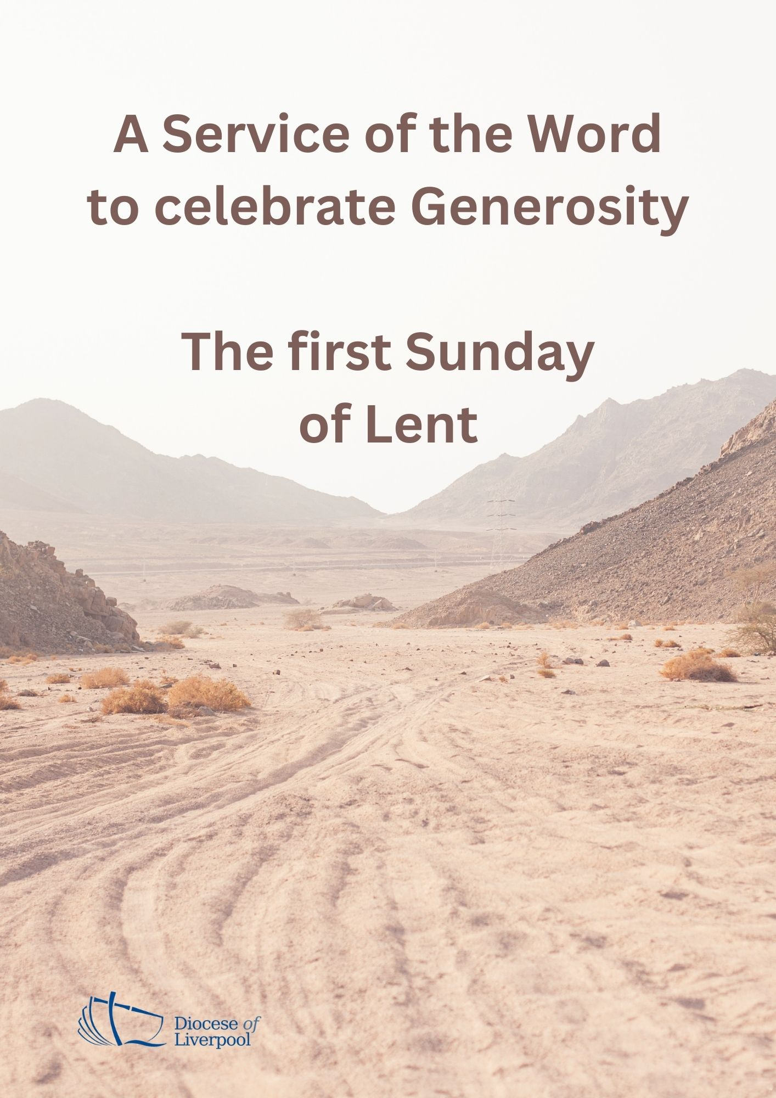

PREPARATION

In preparation for this act of worship, you might wish to pray privately this Prayer of General Thanksgiving.

Accept, O Lord, our thanks and praise for all that you have done for us.

We thank you for the splendour of the whole creation,
for the beauty of this world, for the wonder of life,
and for the mystery of love.

We thank you for the blessing of family and friends,
and for the loving care which surrounds us on every side.

We thank you for setting us at tasks which demand our best efforts,
and for leading us to accomplishments which satisfy and delight us.

We thank you also for those disappointments and failures
that lead us to acknowledge our dependence on you alone.

Above all, we thank you for your Son Jesus Christ;
for the truth of his Word and the example of his life;
for his steadfast obedience, by which he overcame temptation;
for his dying, through which he overcame death;
and for his rising to life again,
in which we are raised to the life of your kingdom.

Grant us the gift of your Spirit,
that we may know him and make him known;
and through him, at all times and in all places,
may give thanks to you in all things. Amen.
Prayer of General Thanksgiving, BCP New York 1979
PREPARATION

In the name of the Father,
and of the Son,
and of the Holy Spirit.
Amen.

Now as you excel in everything, in faith, in speech, in knowledge,
in complete earnestness and in the love we have kindled in you,
see that you also excel in this grace of giving.
2 Corinthians 8:7

A prayer for generous discipleship
God of grace, ever creating and restoring,
you breathe life into all things
and embrace us with an everlasting love;
help us to grow in wonder and awe,
to embody a spirit of gratitude,
and to dream generous dreams;
that, in gathering what we have,
we may graciously offer ourselves
to accomplish what you will,
in Jesus Christ our Lord.
Amen.

Prayers of Penitence

Remember how the Lord your God led you all the way in the wilderness these forty years, to humble and test you in order to know what was in your heart, whether or not you would keep his commands. Observe the commands of the Lord your God, walking in obedience to him and revering him. (Deut 8:2,6)

Creative God, you have gifted us with your creation,
yet we take your good gifts for granted;
Lord, have mercy.
Lord, have mercy.

Gracious God, you bless us each day,
yet we forget to be thankful;
Christ, have mercy.
Christ, have mercy.

Generous God, you offer new life through your Son,
yet we turn away from you;
Lord, have mercy.
Lord, have mercy.

May God who loved the world so much
that he sent his Son to be our Saviour
forgive us our sins
and make us holy to serve him in the world,
through Jesus Christ our Lord.
Amen.

Canticle: A Song of David
Splendour and majesty are yours, O God;
you are exalted as head over all.
1 Blessed are you, God of Israel, for ever and ever,
for yours is the greatness, the power,
the glory, the splendour and the majesty.
2 Everything in heaven and on earth is yours;
yours is the kingdom, O Lord,
and you are exalted as head over all.
3 Riches and honour come from you
and you rule over all.
4 In your hand are power and might;
yours it is to give power and strength to all.
5 And now we give you thanks, our God,
and praise your glorious name.
6 For all things come from you,
and of your own have we given you. 1 Chronicles 29.10b-13,
Glory to the Father and to the Son
and to the Holy Spirit;
as it was in the beginning is now
and shall be for ever. Amen.
Splendour and majesty are yours, O God;
you are exalted as head over all.

The Collect
Almighty God, whose Son Jesus Christ fasted forty days in the wilderness,
and was tempted as we are, yet without sin:
give us grace to discipline ourselves in obedience to your Spirit;
and, as you know our weakness,
so may we know your power to save;
through Jesus Christ your Son our Lord,
who is alive and reigns with you,
in the unity of the Holy Spirit,
one God, now and for ever.
Amen.

God, from whom all good things come,
you shower us with blessings
and you make us stewards of your world;
give us generous hearts,
make us cheerful givers,
filled with desire to see the dawning of the Kingdom
of your Son our Saviour Jesus Christ.
Amen (Diocese of Gloucester)

A children's talk or an all age activity may take place at this point

THE LITURGY OF THE WORD
The First Reading
And now, brothers and sisters, we want you to know about the grace that God has given the Macedonian churches. In the midst of a very severe trial, their overflowing joy and their extreme poverty welled up in rich generosity. For I testify that they gave as much as they were able, and even beyond their ability. Entirely on their own, they urgently pleaded with us for the privilege of sharing in this service to the Lord’s people. And they exceeded our expectations: They gave themselves first of all to the Lord, and then by the will of God also to us.

So we urged Titus, just as he had earlier made a beginning, to bring also to completion this act of grace on your part. But since you excel in everything - in faith, in speech, in knowledge, in complete earnestness and in the love we have kindled in you - see that you also excel in this grace of giving.

I am not commanding you, but I want to test the sincerity of your love by comparing it with the earnestness of others. For you know the grace of our Lord Jesus Christ, that though he was rich, yet for your sake he became poor, so that you through his poverty might become rich.
(2 Corinthians 8:1-9)

This is the Word of the Lord.
Thanks be to God.

Psalmody: Psalm 145

All your works praise you, Lord.

3 Great is the Lord and most worthy of praise;
his greatness no one can fathom.
4 One generation commends your works to another;
they tell of your mighty acts.
5 They speak of the glorious splendour of your majesty
and I will meditate on your wonderful works.
6 They tell of the power of your awesome works
and I will proclaim your great deeds.
7 They celebrate your abundant goodness
and joyfully sing of your righteousness.
8 The Lord is gracious and compassionate,
slow to anger and rich in love.
9 The Lord is good to all;
he has compassion on all he has made.
10 All your works praise you, Lord;
your faithful people praise you. (Psalm 145:3-10)

Glory to the Father and to the Son
and to the Holy Spirit;
as it was in the beginning is now
and shall be for ever. Amen.

All your works praise you, Lord.

Second Reading

Hear the Gospel of our Lord Jesus Christ, according to Matthew.
Glory to you, O Lord.

As soon as Jesus was baptized, he went up out of the water. At that moment heaven was opened, and he saw the Spirit of God descending like a dove and alighting on him. And a voice from heaven said, “This is my Son, whom I love; with him I am well pleased.”

Then Jesus was led by the Spirit into the wilderness to be tempted by the devil. After fasting forty days and forty nights, he was hungry. The tempter came to him and said, “If you are the Son of God, tell these stones to become bread.” Jesus answered, “It is written: ‘Man shall not live on bread alone, but on every word that comes from the mouth of God.’"

Then the devil took him to the holy city and had him stand on the highest point of the temple. “If you are the Son of God,” he said, “throw yourself down. For it is written:
“‘He will command his angels concerning you,
and they will lift you up in their hands,
so that you will not strike your foot against a stone.’”
Jesus answered him, “It is also written: ‘Do not put the Lord your God to the test.’”

Again, the devil took him to a very high mountain and showed him all the kingdoms of the world and their splendour. “All this I will give you,” he said, “if you will bow down and worship me.” Jesus said to him, “Away from me, Satan! For it is written: ‘Worship the Lord your God, and serve him only.’” Then the devil left him, and angels came and attended him.
(Matthew 3:16-4:11)

This is the Gospel of the Lord.
Praise to you, O Christ.

The Sermon
Affirmation of Faith

Let us affirm our faith in Jesus Christ the Son of God.

Though he was divine,
he did not cling to equality with God,
but made himself nothing.
Taking the form of a slave,
he was born in human likeness.

He humbled himself
and was obedient to death,
even the death of the cross.
Therefore God has raised him on high,
and given him the name above every name:
that at the name of Jesus
every knee should bow,
and every voice proclaim that Jesus Christ is Lord,
to the glory of God the Father.
Amen.
Philippians 2.6-11

PRAYERS
A Litany of Generosity
Let us give thanks to God
for his gifts so generous given to us,
and for the blessings we are called to share.

For recognising that all things come from you,
for remembering that we are stewards of your gifts,
for wisely using the resources entrusted to us.
We offer ourselves to you, O God.
For rejoicing in the beauty of creation,
for the care of your world,
for sharing the fruits of creation equally among all people.
We offer ourselves to you, O God.

For encountering the joy of giving,
for humility in putting others’ needs before our own,
for embracing the privilege of sharing in the ministry to the saints.
We offer ourselves to you, O God.

For courage in offering sacrificial generosity,
for giving to be an act of worship,
for grace in offering our souls and bodies to be a living sacrifice.
We offer ourselves to you, O God.

For all financial gifts offered to your Church,
for freely giving as we have received,
for giving and not counting the cost.
We offer ourselves to you, O God.

For releasing our hold on material possessions,
for contentment in what we have,
for trust in letting go.
We offer ourselves to you, O God.

For generosity in love, encouragement and hope,
for openness in invitation and hospitality,
for wisdom in the gift of friendship.
We offer ourselves to you, O God.

For serving you as you deserve,
for following our calling as your disciples,
for serving you with gladness of heart.
We offer ourselves to you, O God.

For being a blessing through the blessings we receive,
for generosity which enables mission,
for sharing abundantly in every good work.
We offer ourselves to you, O God.

For living a generous life,
for our actions to point beyond themselves,
for our generosity to be an expression of love and gratitude.
We offer ourselves to you, O God.

Intercessions
We pray for God's grace.
Lord, receive our praise
And hear our prayer.

Lord God, through your grace we are your people:
Through your Son you have redeemed us;
In your Spirit you have made us your own.

We pray for the life and ministry of our church…
Make our hearts respond to your love.
Lord, receive our praise
And hear our prayer.

We pray for our community, our country and our world…
Make our lives bear witness to your glory in the world
Lord, receive our praise
And hear our prayer.

We pray for all those in need at this time….
Make our wills eager to obey, our hands ready to heal.
Lord, receive our praise
And hear our prayer.

We give thanks for those who have died and pray for those who grieve with sorrow and remember with joy. Especially we pray for…
Lord, receive our praise
And hear our prayer. (Diocese of Gloucester: adapted)

Merciful Father
accept these prayers for the sake of your Son,
our Saviour Jesus Christ. Amen.

The Offering

An offering is taken, which may be virtual,
giving time for people to reflect on gifts given electronically.

God of all creation,
you have blessed us with many gifts
and stir up within us generous hearts.
We give you our thanks,
for all that has been given to us
and in all that is offered back to you in worship,
gifts of gratitude, given in many ways;
in the name of Jesus Christ. Amen

THE DISMISSAL

The God of grace enrich us in every way,
with hearts overflowing with thanksgiving to God;
and the blessing of God almighty,
the Father, the Son, and the Holy Spirit,
be among you and remain with you always.
Amen.

Material in this order of service is taken from Common Worship, copyright © The Archbishops’ Council 2000-2006 and is used here with permission. www.commonworship.com. Gloucester material is from Giving for Life Liturgical Material; Rev Tom Clammer; by permission. This order has been compiled by Sammi Tooze and the diocese of Liverpool.

