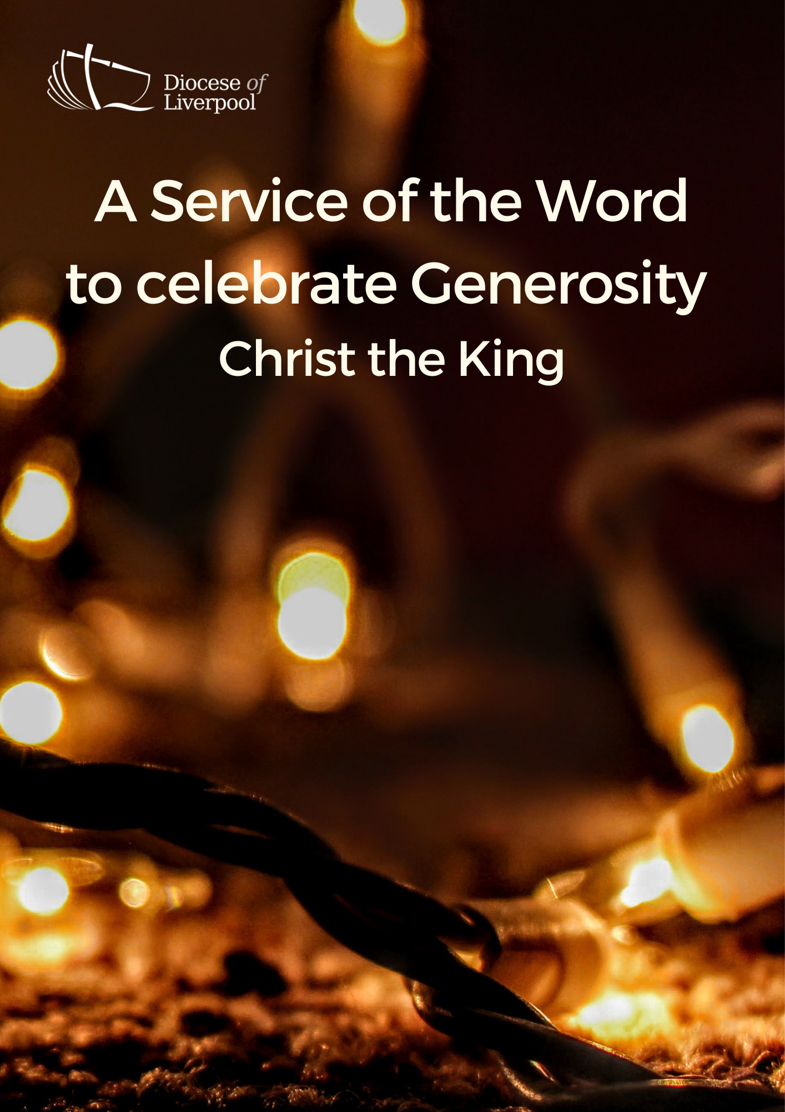

PREPARATION

In preparation for this act of worship, you might wish to pray privately this Prayer of General Thanksgiving.

Accept, O Lord, our thanks and praise for all that you have done for us.

We thank you for the splendour of the whole creation,
for the beauty of this world, for the wonder of life,
and for the mystery of love.

We thank you for the blessing of family and friends,
and for the loving care which surrounds us on every side.

We thank you for setting us at tasks which demand our best efforts,
and for leading us to accomplishments which satisfy and delight us.

We thank you also for those disappointments and failures
that lead us to acknowledge our dependence on you alone.

Above all, we thank you for your Son Jesus Christ;
for the truth of his Word and the example of his life;
for his steadfast obedience, by which he overcame temptation;
for his dying, through which he overcame death;
and for his rising to life again,
in which we are raised to the life of your kingdom.

Grant us the gift of your Spirit,
that we may know him and make him known;
and through him, at all times and in all places,
may give thanks to you in all things. Amen.
Prayer of General Thanksgiving, BCP New York 1979
PREPARATION

In the name of the Father,
and of the Son,
and of the Holy Spirit.
Amen.

God is able to provide us with every blessing in abundance,
so that by always having enough of everything,
we may share abundantly in every good work.
cf. 2 Corinthians 9.8

Enter the gates of the Lord with thanksgiving,
and enter his courts with praise.
Give thanks to the Lord
and bless his name.
For the Lord is good;
his steadfast love endures forever. cf. Psalm 100.4-5

For the gift of his Spirit: blessed be Christ.
For the catholic Church: blessed be Christ.
For the means of grace: blessed be Christ.
For the hope of glory: blessed be Christ.
For the triumphs of his gospel: blessed be Christ.
For the lives of his saints: blessed be Christ.
In joy and In sorrow: blessed be Christ.
In life and in death: blessed be Christ.
Now and to the end of the ages: blessed be Christ.
(Church in Wales, Daily Prayer)

Prayers of Penitence

When our natural fears and anxieties push you
to the margins of our lives,
Lord, have mercy.
Lord, have mercy.

When we are so preoccupied with our concerns
that we cannot seek first your kingdom or put our trust in you,
Christ, have mercy.
Christ, have mercy.

When disappointment leads to doubt,
when fear hinders faith and we cannot see the glory which will be,
Lord, have mercy.
Lord, have mercy.

Almighty God,
who in Jesus Christ has given us
a kingdom that cannot be destroyed,
forgive us our sins,
open our eyes to God’s truth,
strengthen us to do God’s will
and give us the joy of his kingdom,
through Jesus Christ our Lord.
Amen.

Canticle: A Song of David
Splendour and majesty are yours, O God;
you are exalted as head over all.
1 Blessed are you, God of Israel, for ever and ever,
for yours is the greatness, the power,
the glory, the splendour and the majesty.
2 Everything in heaven and on earth is yours;
yours is the kingdom, O Lord,
and you are exalted as head over all.
3 Riches and honour come from you
and you rule over all.
4 In your hand are power and might;
yours it is to give power and strength to all.
5 And now we give you thanks, our God,
and praise your glorious name.
6 For all things come from you,
and of your own have we given you. 1 Chronicles 29.10b-13,
Glory to the Father and to the Son
and to the Holy Spirit;
as it was in the beginning is now
and shall be for ever. Amen.
Splendour and majesty are yours, O God;
you are exalted as head over all.

The Collect
God the Father,
help us to hear the call of Christ the King
and to follow in his service,
whose kingdom has no end;
for he reigns with you and the Holy Spirit,
one God, one glory. Amen.

A children's talk or an all age activity may take place at this point
THE LITURGY OF THE WORD
The First Reading
In the second year of King Darius, on the first day of the sixth month, the word of the Lord came through the prophet Haggai to Zerubbabel son of Shealtiel, governor of Judah, and to Joshua son of Jozadak, the high priest: This is what the Lord Almighty says: ‘These people say, “The time has not yet come to rebuild the Lord’s house.”’
Then the word of the Lord came through the prophet Haggai: ‘Is it a time for you yourselves to be living in your panelled houses, while this house remains a ruin?’ Now this is what the Lord Almighty says: ‘Give careful thought to your ways. You have planted much, but harvested little. You eat, but never have enough. You drink, but never have your fill. You put on clothes, but are not warm. You earn wages, only to put them in a purse with holes in it.’
This is what the Lord Almighty says: ‘Give careful thought to your ways. Go up into the mountains and bring down timber and build my house, so that I may take pleasure in it and be honoured,’ says the Lord. ‘You expected much, but see, it turned out to be little. What you brought home, I blew away. Why?’ declares the Lord Almighty. ‘Because of my house, which remains a ruin, while each of you is busy with your own house. Therefore, because of you the heavens have withheld their dew and the earth its crops. I called for a drought on the fields and the mountains, on the grain, the new wine, the olive oil and everything else the ground produces, on people and livestock, and on all the labour of your hands.’
Then Zerubbabel son of Shealtiel, Joshua son of Jozadak, the high priest, and the whole remnant of the people obeyed the voice of the Lord their God and the message of the prophet Haggai, because the Lord their God had sent him. And the people feared the Lord.
Then Haggai, the Lord’s messenger, gave this message of the Lord to the people: ‘I am with you,’ declares the Lord. So the Lord stirred up the spirit of Zerubbabel son of Shealtiel, governor of Judah, and the spirit of Joshua son of Jozadak, the high priest, and the spirit of the whole remnant of the people. They came and began to work on the house of the Lord Almighty, their God, on the twenty-fourth day of the sixth month. Haggai 1:1-15

Psalmody: Psalm 93

The Lord shall reign for ever and ever.

1 The Lord is king and has put on glorious apparel;
the Lord has put on his glory
and girded himself with strength.
2 He has made the whole world so sure
that it cannot be moved.
3 Your throne has been established from of old;
you are from everlasting.
4 The floods have lifted up, O Lord,
the floods have lifted up their voice;
the floods lift up their pounding waves.
5 Mightier than the thunder of many waters,
mightier than the breakers of the sea,
the Lord on high is mightier.
6 Your testimonies are very sure;
holiness adorns your house, O Lord, for ever.

Glory to the Father and to the Son
and to the Holy Spirit;
as it was in the beginning is now
and shall be for ever. Amen.

The Lord shall reign for ever and ever.

Second Reading

Hear the Gospel of our Lord Jesus Christ, according to Matthew.
Glory to you, O Lord.

Hear the Gospel of our Lord Jesus Christ, according to John.
Glory to you, O Lord.

Pilate then went back inside the palace, summoned Jesus and asked him, ‘Are you the king of the Jews?’ ‘Is that your own idea,’ Jesus asked, ‘or did others talk to you about me?’

‘Am I a Jew?’ Pilate replied. ‘Your own people and chief priests handed you over to me. What is it you have done?’ Jesus said, ‘My kingdom is not of this world. If it were, my servants would fight to prevent my arrest by the Jewish leaders. But now my kingdom is from another place.’

‘You are a king, then!’ said Pilate. Jesus answered, ‘You say that I am a king. In fact, the reason I was born and came into the world is to testify to the truth. Everyone on the side of truth listens to me.’
John 18:33-37

This is the Gospel of the Lord.
Praise to you, O Christ.

The Sermon
Affirmation of Faith

Let us affirm our faith in Jesus Christ the Son of God.

Though he was divine,
he did not cling to equality with God,
but made himself nothing.
Taking the form of a slave,
he was born in human likeness.

He humbled himself
and was obedient to death,
even the death of the cross.
Therefore God has raised him on high,
and given him the name above every name:
that at the name of Jesus
every knee should bow,
and every voice proclaim that Jesus Christ is Lord,
to the glory of God the Father.
Amen.
cf Philippians 2.6-11

PRAYERS
A Litany of Generosity
Let us give thanks to God
for his gifts so generous given to us,
and for the blessings we are called to share.

For recognising that all things come from you,
for remembering that we are stewards of your gifts,
for wisely using the resources entrusted to us.
We offer ourselves to you, O God.
For rejoicing in the beauty of creation,
for the care of your world,
for sharing the fruits of creation equally among all people.
We offer ourselves to you, O God.

For encountering the joy of giving,
for humility in putting others’ needs before our own,
for embracing the privilege of sharing in the ministry to the saints.
We offer ourselves to you, O God.

For courage in offering sacrificial generosity,
for giving to be an act of worship,
for grace in offering our souls and bodies to be a living sacrifice.
We offer ourselves to you, O God.

For all financial gifts offered to your Church,
for freely giving as we have received,
for giving and not counting the cost.
We offer ourselves to you, O God.

For releasing our hold on material possessions,
for contentment in what we have,
for trust in letting go.
We offer ourselves to you, O God.

For generosity in love, encouragement and hope,
for openness in invitation and hospitality,
for wisdom in the gift of friendship.
We offer ourselves to you, O God.

For serving you as you deserve,
for following our calling as your disciples,
for serving you with gladness of heart.
We offer ourselves to you, O God.

For being a blessing through the blessings we receive,
for generosity which enables mission,
for sharing abundantly in every good work.
We offer ourselves to you, O God.

For living a generous life,
for our actions to point beyond themselves,
for our generosity to be an expression of love and gratitude.
We offer ourselves to you, O God.

Intercessions

The Lord says, ‘My house remains a ruin, while each of you is busy with their own house.’
Lord, we pray for the ministry and mission of this church. Set us free from the fearfulness that turns us inward. Grant a renewed vision of what it is for us to be your church, in this place, at this time. [Especially we pray for … ]
Stir up our spirits Lord,
that we might see your glory in our midst.
The Lord says, ‘Give careful thought to your ways.
Lord, help us to know that you are the owner and giver of all we have. Grant us grace to consider our lifestyles, our money choices and our financial goals so that you may be Lord of all. [Especially we pray for …]
Stir up our spirits Lord,
that we might see your glory in our midst.
'I The Lord says, 'I am with you'.
Lord, you have promised to provide all we need. But our hearts are anxious, for ourselves, our loved ones, our community, our nation. We pray for all those who struggle. [Especially we pray for …]
Stir up our spirits Lord,
that we might see your glory in our midst.
The Lord says, ‘Be strong, for I am with you. My Spirit remains among you. Do not fear.'
Lord we remember before you those who struggle in mind, body or spirit [remembering especially …] We remember also those who have died and those who live now with the pain of bereavement, [remembering especially …] Grant, to each Lord, your promise that,’ In this place I will grant peace.’
Stir up our spirits Lord,
that we might see your glory in our midst.
The Lord says, ‘This people say, the time has not yet come to rebuild the Lord's house
Lord, give us grace to stay faithful and centred on you. Keep us from holding you at the margins of our lives. Instead, let our lives declare the glory of your presence, in our hearts and homes, in our church and in our nation.
Grant us the right attitude towards our possessions
and a generous heart in the use of the gifts that you give to us;
that by our actions we may glorify you,
with the Father and the Holy Spirit, one God, now and for ever. Amen.
Merciful Father
accept these prayers for the sake of your Son,
our Saviour Jesus Christ. Amen.

The Offering

An offering is taken, which may be virtual,
giving time for people to reflect on gifts given electronically.

God of all creation,
you have blessed us with many gifts
and stir up within us generous hearts.
We give you thanks
for all that has been offered back to you,
gifts of gratitude, given in many ways;
in the name of Jesus Christ.
Amen

THE DISMISSAL

The God of grace enrich us in every way,
with hearts overflowing with thanksgiving to God;
and the blessing of God almighty,
the Father, the Son, and the Holy Spirit,
be among you and remain with you always.
Amen.

Material in this order of service is taken from Common Worship, copyright © The Archbishops’ Council 2000-2006 and is used here with permission. www.commonworship.com. This order has been compiled by Sammi Tooze.

