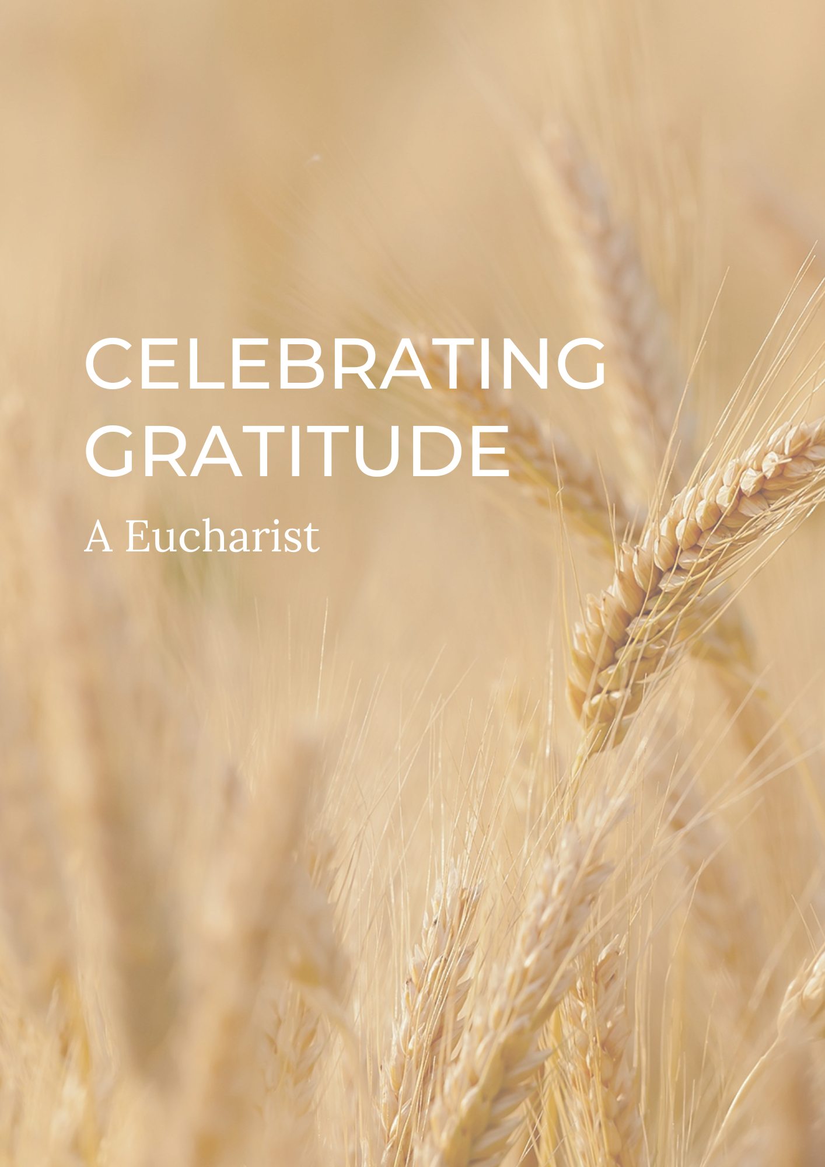

PREPARATION

In preparation for this act of worship, you might wish to pray privately this Prayer of General Thanksgiving.

Accept, O Lord, our thanks and praise for all that you have done for us.
We thank you for the splendour of the whole creation,
for the beauty of this world, for the wonder of life,
and for the mystery of love.

We thank you for the blessing of family and friends,
and for the loving care which surrounds us on every side.

We thank you for setting us at tasks which demand our best efforts,
and for leading us to accomplishments which satisfy and delight us.

We thank you also for those disappointments and failures
that lead us to acknowledge our dependence on you alone.

Above all, we thank you for your Son Jesus Christ;
for the truth of his Word and the example of his life;
for his steadfast obedience, by which he overcame temptation;
for his dying, through which he overcame death;
and for his rising to life again,
in which we are raised to the life of your kingdom.

Grant us the gift of your Spirit,
that we may know him and make him known;
and through him, at all times and in all places,
may give thanks to you in all things. Amen.

Prayer of General Thanksgiving, BCP New York 1979
THE GATHERING

In the name of the Father,
and of the Son,
and of the Holy Spirit.
Amen.

Enter the gates of the Lord with thanksgiving,
and enter his courts with praise.
Give thanks to the Lord
and bless his name.
For the Lord is good;
his steadfast love endures forever. cf. Psalm 100.4-5

Words of welcome or introduction may be said.

Prayers of Penitence

As those who know the generosity of God,
let us confess our sins,
especially the ways in which we take his good gifts for granted.

Creative God, you have gifted us with your creation,
yet we take your good gifts for granted;
Lord, have mercy.
Lord, have mercy.

Gracious God, you bless us each day,
yet we forget to be thankful;
Christ, have mercy.
Christ, have mercy.
Generous God, you offer new life through your Son,
yet we turn away from you;
Lord, have mercy.
Lord, have mercy.

May God who loved the world so much
that he sent his Son to be our Saviour
forgive us our sins
and make us holy to serve him in the world,
through Jesus Christ our Lord.
Amen.

Gloria in Excelsis

Gloria in excelsis may be used.

Glory to God in the highest,
and peace to his people on earth.
Lord God, heavenly King,
almighty God and Father,
we worship you, we give you thanks,
we praise you for your glory.
Lord Jesus Christ, only Son of the Father,
Lord God, Lamb of God,
you take away the sin of the world:
have mercy on us;
you are seated at the right hand of the Father:
receive our prayer.
For you alone are the Holy One,
you alone are the Lord,
you alone are the Most High, Jesus Christ,
with the Holy Spirit,
in the glory of God the Father. Amen.
The Collect

In a time of silence,
let us pray that we may draw closer
to the one who has created all things.

Silence is kept.

God of grace, ever creating and restoring,
you breathe life into all things
and embrace us with an everlasting love;
help us to grow in wonder and awe,
to embody a spirit of gratitude,
and to dream generous dreams;
that, in gathering what we have,
we may graciously offer ourselves
to accomplish what you will,
in Jesus Christ our Lord.
Amen.

THE LITURGY OF THE WORD

The First Reading

Ruth chapters three and four

Gospel Reading

Hear the Gospel of our Lord Jesus Christ, according to Luke.
Glory to you, O Lord.

Jesus entered Jericho and was passing through. A man was there by the name of Zacchaeus; he was a chief tax collector and was wealthy. He wanted to see who Jesus was, but because he was short he could not see over the crowd. So he ran ahead and climbed a sycamore-fig tree to see him, since Jesus was coming that way.

When Jesus reached the spot, he looked up and said to him, ‘Zacchaeus, come down immediately. I must stay at your house today.’ So he came down at once and welcomed him gladly.

All the people saw this and began to mutter, ‘He has gone to be the guest of a sinner.’ But Zacchaeus stood up and said to the Lord, ‘Look, Lord! Here and now I give half of my possessions to the poor, and if I have cheated anybody out of anything, I will pay back four times the amount.’

Jesus said to him, ‘Today salvation has come to this house, because this man, too, is a son of Abraham. For the Son of Man came to seek and to save the lost.’’
Luke 19:1-10 (NIV)

This is the Gospel of the Lord.
Praise to you, O Christ.

A sermon may be given.

The Creed

We believe in one God,
the Father, the Almighty,
maker of heaven and earth,
of all that is,
seen and unseen.

We believe in one Lord, Jesus Christ,
the only Son of God,
eternally begotten of the Father,
God from God, Light from Light,
true God from true God,
begotten, not made,
of one Being with the Father;
through him all things were made.
For us and for our salvation he came down from heaven,
was incarnate from the Holy Spirit and the Virgin Mary
and was made man.
For our sake he was crucified under Pontius Pilate;
he suffered death and was buried.
On the third day he rose again
in accordance with the Scriptures;
he ascended into heaven
and is seated at the right hand of the Father.
He will come again in glory to judge the living and the dead,
and his kingdom will have no end.

We believe in the Holy Spirit,
the Lord, the giver of life,
who proceeds from the Father and the Son,
who with the Father and the Son is worshipped and glorified,
who has spoken through the prophets.

We believe in one holy catholic and apostolic Church.
We acknowledge one baptism for the forgiveness of sins.
We look for the resurrection of the dead,
and the life of the world to come.
Amen.

PRAYER

A Litany of Thanksgiving

Let us give thanks to God
for his gifts so generous given to us,
and for the blessings we each abundantly receive.

For the beauty of creation,
for the wonder of new life,
for all things seen and unseen.
We give you thanks, O God. Psalm 75.1

For the gift of life that you breathe into us,
for minds to think, hearts to love, and hands to serve.
We give you thanks, O God.

For our families and friends,
for all who we love and who love us,
for your image revealed through those around us.
We give you thanks, O God.

For life of your church,
its vibrancy and diversity,
for the mission in which we all share.
We give you thanks, O God.
For the vocations in which you call us,
for the skills which are nurtured and grow,
for our ministries in all walks of life.
We give you thanks, O God.

For your seed of creativity planted in each person,
for voices to sing our praises to you,
for our capacity to create.
We give you thanks, O God.

For your love which brings us peace even in the darkest of times,
for your strength when we feel weak and vulnerable,
for your hope when all seems lost.
We give you thanks, O God.

For all financial gifts offered to our church,
for blessings offered to be a blessing to others,
for sacrifices made to further mission and enable us to be Christ in the world.
We give you thanks, O God.

For the generosity of this community,
for all who give their time and skills,
for the gifts which are built up and encouraged,
for acts which point beyond themselves and reveal your glory.
We give you thanks, O God.

For you, O God,
for your beauty revealed in all things around us,
for love and life everlasting.
We give you thanks, O God.

For the wisdom of your Spirit,
for gifts given and nurtured,
for sustaining us in prayer.
We give you thanks, O God.

For your Son, Jesus Christ,
for the gift of his perfect sacrifice,
for our hope in him, and the joy of serving his Church.
We give thanks to you, O God.

Intercessions

Intercessions are offered, and may end with;

Source of all life and giver of all that is good,
hear our prayer,
and make us one in heart and mind
to serve you with joy forever.
Amen.

THE LITURGY OF THE SACRAMENT
The Peace

May we be made strong, enduring everything with patience,
while joyfully giving thanks to the Father,
who has enabled us to share in the inheritance of the saints in the light.
cf. Colossians 1.11-12
The peace of the Lord be always with you
and also with you.

All are invited to exchange a sign of peace.
An offering may be taken. There should be time for people to reflect on gifts given electronically. The table is prepared and bread and wine are placed upon it.
Prayer over Offering

God of all creation,
the source of life and giver of all good things;
you have blessed us with all we have.
In our worship we bring now our first fruits:
gifts of gratitude, given in many ways.
With them we offer our lives.
Bless these gifts that they may be used to serve others,
to your praise and glory. Amen.

Taking of the Bread and Wine

Giving God,
from whom comes every good and perfect gift,
that we might grow in gratitude and share your blessings;
accept these gifts of bread and wine,
and may the sacrifice of Christ
draw us closer to you;
through Jesus Christ our Lord.
Amen.

The Eucharistic Prayer

The Lord be with you (or) The Lord is here.
and also with you. His Spirit is with us.
Lift up your hearts.
We lift them to the Lord.
Let us give thanks to the Lord our God.
It is right to give thanks and praise.

Eternal God and Father,
all things are in your making.
In fulfilment of your promise
you have showered us with blessings
and filled us with your gifts.
You form us in your image, the first fruits of your creation,
and by your Holy Spirit embed within us generous hearts
that we may be channels of your self-giving love.
Through your Son Jesus Christ,
you have freed us from our sins
and made us a kingdom of priests
to serve you with joy for ever.

Therefore with angels and archangels,
and with all the company of heaven,
we proclaim your great and glorious name,
for ever praising you and saying:

Holy, holy, holy Lord,
God of power and might,
heaven and earth are full of your glory.
Hosanna in the highest.
Blessed is he who comes in the name of the Lord.
Hosanna in the highest.

We praise and bless you, loving Father,
through Jesus Christ, our Lord;
and as we obey his command,
send your Holy Spirit,
that broken bread and wine outpoured
may be for us the body and blood of your dear Son.

On the night before he died he had supper with his friends
and, taking bread, he praised you.
He broke the bread, gave it to them and said:
Take, eat; this is my body which is given for you;
do this in remembrance of me.

When supper was ended he took the cup of wine.
Again he praised you, gave it to them and said:
Drink this, all of you;
this is my blood of the new covenant,
which is shed for you and for many for the forgiveness of sins.
Do this, as often as you drink it, in remembrance of me.

So, Father, we remember all that Jesus did,
in him we plead with confidence his sacrifice
made once for all upon the cross.
Bringing before you the bread of life and cup of salvation,
we proclaim his death and resurrection
until he comes in glory.

Praise to you, Lord Jesus:
Dying you destroyed our death,
rising you restored our life:
Lord Jesus, come in glory.

Lord of all life,
help us to work together for that day
when your kingdom comes
and justice and mercy will be seen in all the earth.

Look with favour on your people,
gather us in your loving arms
and bring us with [N and] all the saints
to feast at your table in heaven.
Through Christ, and with Christ, and in Christ,
in the unity of the Holy Spirit,
all honour and glory are yours, O loving Father,
for ever and ever.
Amen.

Coming before you with thankful hearts,
as our Saviour taught us, so we pray

Our Father in heaven,
hallowed be your name,
your kingdom come,
your will be done,
on earth as in heaven.
Give us today our daily bread.
Forgive us our sins
as we forgive those who sin against us.
Lead us not into temptation
but deliver us from evil.
For the kingdom, the power,
and the glory are yours
now and for ever.
Amen.

We break this bread to share in the body of Christ.
Though we are many, we are one body,
because we all share in one bread.

(or)

O taste and see that the Lord is gracious;
blessed is the one who trusts in him.

God’s holy gifts
for God’s holy people.
Jesus Christ is holy,
Jesus Christ is Lord,
to the glory of God the Father.

Prayer after Communion

Gracious God,
around your table we taste your generosity and your sacrificial love;
help us to be rooted, grafted and built in you,
that in all we are and all we do,
we may show forth abundant thanksgiving
and live lives of immeasurable gratitude;
through Jesus Christ our Lord. Amen.

THE DISMISSAL
The God of grace enrich us in every way,
with hearts overflowing with thanksgiving to God;
and the blessing of God almighty,
the Father, the Son, and the Holy Spirit,
be among you and remain with you always. Amen.
Go in peace to love and serve the Lord.
In the name of Christ. Amen.

Material in this order of service is taken from Common Worship, copyright © The Archbishops’ Council 2000-2006 and is used here with permission. www.commonworship.com. This order, with adapted offertory prayer, has been compiled by Sammi Tooze. This compilation is copyright © The National Giving Team 2020.

